LeMarchant-St. Thomas School
Parent/Guardian Handbook
2026-27
Phone : 902-421-6769
FAX: (902) 421-3036
Email: lmsts@hrce.ca
Website: https://lmt.hrce.ca/
Instagram: @LMSTSnews
Contents
Welcome to LeMarchant-St. Thomas! 3
4
School Parking & Drop Off 5
Morning Entrance 5
Student Belongings 5
Recess & Lunch 6
Leaving at Lunch Hour 6
School Technology 6
Alphabetized General Information 6
Agendas 6
Appointments 6
Attendance 7
Allergy Alerts 7
Before & After-School Supervision 7
Before & After School Programs 7
Bikes & Scooters 7
Communication 7
Clothing 8
Communicating Student Learning 8
Curriculum 8
Dismissal Changes 8
Library 9
Hot Lunch Program 9
Lost & Found Items 9
Lunch Time 9
Monthly Themes 9
Prescription Medication 10
Recess 10
Safety Drills 10
School Cash Online 10
School Cancellations - Winter 10
Early Closure Procedures for LMST 10
Technology 11
Telephone/Cell Phones/Smart Device Use At School 11
Toys 11
Working Together 11
Visitors 11
Volunteers 12
Policies of Interest 12
Report Cards 12
School Day Schedule 12
LMST’s School Calendar 2026-2027 13

Welcome to LeMarchant-St. Thomas!

Dear Parent/Guardian,

As a parent, you are your child’s first and lifelong teacher. Your knowledge of your child, along with your child’s teacher’s input and understanding, will be critical in shaping your child’s education during their academic journey. The elementary school years for your child are one of the milestones of his/her life and can set the tone for the formative years ahead. Thus, it is very important that these are happy and productive years. We like to consider ourselves an extended family of learners, focused on your child and their classmates and peers.

In this handbook we aim to address the majority of questions that you may encounter during the year while you and your family become accustomed to school days.

Please feel free to ask questions, either in person, email or by telephone, should anything be of concern to you.

Bienvenue! Welcome!

Moira Cavanaugh, Principal Kim Gallivan, Vice Principal


At LeMarchant-St. Thomas, we believe that everyone deserves to be treated with respect and feel safe.

We are committed to building strong, caring relationships with students, staff, and families.

We learn from each other, reflect and move forward from our mistakes.

We grow together every day by engaging in meaningful learning, reflection and connection!

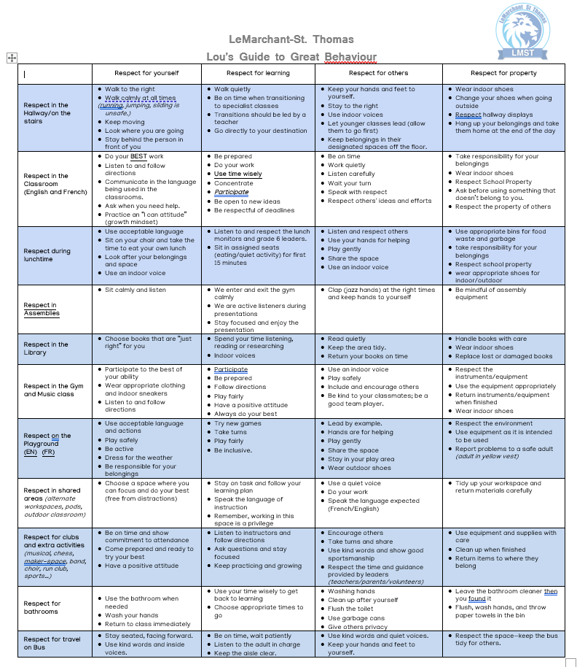

School Parking & Drop Off
LMST does not have onsite parking for families. Please plan on parking on side streets in the neighborhood or walk from home.

Morning Entrance
Classes commence at 8:55 am. Students are expected to be in their classroom ready to learn at this time (specific entrance details are listed below)

- The school will open each day at 8:35 am and students will be asked to enter the building at their designated door upon arrival.
- There will be staff on duty INSIDE the building guiding students to their classroom. Classroom teachers will be in their classroom to receive students.
- Parents are asked to drop students at the assigned door. This will be posted on each door on September 3rd.

Main Entrance doors | Side door (playground side)/  Southwest door/ Watt Street entrance | Side door (playground side)  closest to the field/ Northwest door/Field entrance
Primary/1 Drapeau (purple) | 3/4 Boyle | 1 Roberge (red)
Primary Lacroix (blue) | 3 LeDuc | 1/2 Larocque (gold)
Primary DePalma(green) | 4 Smith | 2/3 Morrisey (brown)
Primary/1 Rhynold (pink) | 5 Duguay-Myatt | 2 Chisholm (light green)
Primary Zelios (yellow) | 5/6 Ellis | 3 Collinson
1 Abi Daoud (orange) | 5/6 Cunningham | 3/4 Ottosen
2 Jordan (silver) | 6 Chiasson | 4 Beaton
 | 6 Trach | 4/5 Michelin
 |  | 5 Mouland

2 Englehutt – students proceed to portable via the playground.
2/3 Fennell – students proceed to portable via the playground.

Student Belongings
Students are asked to bring all school supplies over the first week of school unless otherwise indicated by a homeroom teacher. Students will hang their bags and coats in their cubbies each day.

School Grounds
Staff will be on duty during school hours to review and teach expectations with the students. Lunch playtime has been divided into 2 blocks:
11:55-12:25 p.m 3-6 Outside, P-2/3 Inside
12:25-12:50 p.m P-2/3 Outside, 3-6 Inside

Recess & Lunch
Students will be eating in their classroom.
- Parents/guardians please send child (ren) with a packed lunch each day in an insulated lunch
bag as there is no access to microwaves or refrigerators if children do not receive hot lunch through the Provincial School Lunch Program
- Please be sure to pack utensils, napkins, and easily opened packaging that your child can manage with independence. This may require daily practice for younger students prior to school entry to reduce frustration and wait time.
- It will be beneficial to also teach them how to put items back in their lunch bag when they have finished eating! They can do it!
- Students going home for lunch are expected to return to school grounds at/before the 12:50 pm bell. Please let your child’s teacher know if your child will be going home for lunch.
- Parents/guardians with specific dietary/health issues are asked to contact the school directly so special arrangements or planning can be made.
- Please send your child to school with a pair of indoor shoes. This will keep our new school clean, including our gymnasium.

Leaving at Lunch Hour
- Students in grades P-6 are not allowed to leave to go to the store or a restaurant unless accompanied by a parent/guardian
- Children are not permitted to buy candy/treats and bring them back to school, including for afterschool EXCEL students.
- There is no need for students to have money at school.
- We appreciate your support!

Technology
LMST follows the NSEECD Cell Phone Directive for Nova Scotia released on June 6, 2024. Continuing with our school policy last year, all students are asked to:

- Refrain from bringing technology and smart devices to school
- All smart devices (watches, phones, etc.) are to stay in student backpacks and powered off when at school.

We encourage families to read the policy: https://www.ednet.ns.ca/docs/pandireleaseprovincialdirectiveoncellphoneuseinschoolsen.pdf

Alphabetized General Information

Agendas
Primary-3 classes receive agendas in September. Parents/guardians are encouraged to check the agenda every night to receive important information from the teacher and school. Agenda and email are often the primary modes of communication between parents/guardians and teachers.

Appointments
Often, children do have appointments during the day. Please email your child’s teacher and the main office at lmtsa@hrce.ca with as much notice as possible if your child has an appointment and will be late or needs to be picked up early. Please be mindful that teachers do not monitor emails during instructional time. For more important information regarding attendance changes, please also refer to Dismissal Changes.

Attendance
To ensure the safety of our students, attendance is taken each morning and afternoon. We have launched a new way to report absences through SchoolMessenger. You are able to report future absences using an app, website, or toll-free phone number. If your student is absent and the absence has not been reported in advance, you will receive notifications via email, text, and phone calls from SchoolMessenger. If SchoolMessenger cannot reach you, office staff will follow up.

To report on your student absence, you can use any of the following methods:
PowerSchool Parent/Student Portal (https://sishrsb.ednet.ns.ca/public/)
SchoolMessenger App
Toll-Free Number (1-833-582-6940)

Please note: SchoolMessenger only allows parents to report a student as "Absent with Notification." This can be used for absences or late arrivals. When the student arrives at school, they must check in at the office. The Administration team will update the attendance record.

Allergy Alerts
LMST has a Peanut/Allergy Alert policy as some students are highly allergic to these substances. The HRCE Life-Threatening Allergies Policy governs our school actions with regard to students who are allergic to certain, identified, physician-confirmed allergens. Students with severe allergies will be required to fill out information sheets to be maintained in the office and to provide, if necessary, an epi-pen for emergency treatment. Students with epi-pens must have them with them at all times.

Before & After-School Supervision
Please note there is no teacher supervision before or after school. At dismissal time (2:55pm), staff are responsible for dismissing students and to ensure that they are received and supervised by either the parent or parent/guardian-designated caregiver. For safety reasons, students cannot remain unsupervised on school grounds. Please note that students must be promptly picked up at dismissal time. For safety reasons students are not permitted to reenter the school once dismissed for the day.

Before & After School Programs
Excel is the only external provider for before and after school programs that is provided space in the school. There are programs offered in the vicinity. Below are some contact numbers:
- Excel (902) 464-2000 (ext. 2013)
- University Children’s Centre (902) 494-1754
- Peter Green Hall 902 494 1747

Bikes & Scooters
Bikes will be stored outdoors on school grounds. Students who ride bicycles/scooters to school should:
- Refrain from driving any bike or scooter on school property during school hours.
- Walk the bicycle/scooter to the designated rack area once on school property.
- Always lock the bicycle / scooter at the rack. There is a limited number of scooter racks inside the side doors (by Watt and by the field)
- Students are responsible for looking after their own helmets.

The school is not responsible for lost or damaged bicycles / scooters.

Communication
LMST utilizes various communication methods to get information home from the school.
- Website: http://lmt.hrce.ca/ Please use this as your first place to look.
- Instagram: @LMSTSnews
- Agenda: Some Primary to Grade Three students will be provided with an agenda for listing daily assignments, project work and school messages. Your cooperation in regular checking of the agenda is most appreciated by the staff.
- Newsletter: along with a calendar that is updated on our school website regularly. Classroom teachers also may have their own form of newsletter/memo to keep you up to date with what is going on in your child’s classroom.
- SchoolMessenger: We send communication to families at times during SchoolMessenger. More information on school messenger can be found at: https://go.schoolmessenger.com/#/home
- Email: Emails will also be a form of communication.
- Instagram: our LMST handle is @lmstnews

NOTE: If you do not receive communication from the school by the first week of September, please contact the office to ensure we have your most up to date contact information.

Clothing
Shoes/footwear must be always worn inside the building.
- A pair of indoor sneakers is important to have for use in the classroom and gymnasium, as outdoor shoes have many contaminants on them which end up in the classroom.
- Recess and Lunch will be held outdoors in all conditions. The major consideration besides warmth is to purchase clothing that the child can put on with independence.
- Water resistant mittens are advised. Please send some extra mittens along as a backup.
- Please make sure all clothing is clearly labeled.
- A change of clothes in a plastic bag in your child’s backpack is recommended for Grades P-3.
- LMST does have an account with Mabel’s Labels (https://mabelslabels.ca/en_CA/)

Communicating Student Learning
We feel that it is important to communicate clearly and frequently with parents/guardians about their children’s progress in school.
- Teachers gather information about what students learn, how they learn, and the growth they have made in a variety of ways.
- Teachers use balanced assessment to give students multiple opportunities to demonstrate their knowledge, skills and attitudes.
- When concerns arise about a student’s progress, parents are asked to first discuss the matter with the teachers. If the matter is not resolved, the parent should approach the school administration for further assistance in problem solving.
- Major communication touchpoints include report cards, interviews, portfolios and work sent home.

Curriculum
All areas of curriculum are issued from the NS Department of Education and Early Childhood Development (EECD), under the Public-School Programs at: https://curriculum.novascotia.ca/.

Dismissal Changes
- A note in the agenda or an email to the school (homeroom teacher and main office at lmtsa@hrce.ca) indicating the time and date of early pick-up will help remind the child. Please indicate when someone other than a parent will be picking up your child. Also, please be mindful that teachers do not monitor email accounts during instructional time.
- It is preferable to have this information given to the teacher in the morning rather than calling the school.
- Please indicate when your child needs alternate dismissal arrangements for the end of the day.
- Last-minute notification is often difficult due to the volume of phone calls and classes in different locations within the school. Requests for early dismissal will not be taken after 2:40pm unless it is an emergency.
- Playdates are to be arranged with parents/guardians outside of school hours and before the school day begins.

Library
Classes visit the library on a weekly basis. Students are able to borrow books for use in the classroom and at home. Please support your child’s teacher in developing good habits in returning books on time.

Hot Lunch Program
The Nova Scotia School Lunch Program is a provincial lunch program that offers LMST students’ nutritious lunch every school day. Ordering will open on Friday mornings and close on Wednesday at noon.

More information on the School Lunch Program can be found at https://nslunch.ca/

Lost & Found Items
Without a doubt school can be a place where you can always encounter a mystery! “Who owns this” or “I can’t find my...” Many of these mysteries could be solved if everything your child brings to school is labeled.
- All clothing, which is not claimed in the classroom, is placed in the Lost and Found bins.
- Several times a year (usually on Parent-Guardian/Teacher Interview days) remaining articles on display for retrieval.
- Remaining articles are then donated.

Lunch Time
All students may stay for lunch at the school free of charge. Lunch time is 50 minutes long. Please inform your child’s teacher about his/her lunch plans.
- LMST is part of the Provincial School Lunch Program. Link here: https://nslunch.ca/
- Wrappers will be sent home in lunch boxes.
- LMST is a peanut aware zone and students are not permitted to bring foods with nuts or peanuts.
- Microwaves are not available. Your teacher may be in touch regarding further allergies.
- Please pack utensils needed in your child’s lunch.

Thank you for your cooperation in this area!

Monthly Themes
Each month we follow a monthly theme that align well with Caring Schools Community. This integrated curriculum program promotes a positive and safe learning environment by teaching respect and dignity for every person and to promote the well-being of every individual within our school. Our schedule will be as follows:
- September- Friendliness
- October- Gratitude
- November-Respect
- December-Generosity
- January- Empathy
- February- Kindness
- March- Perseverance
- April- Acceptance
- May- Honesty/Integrity
- June- Teamwork

Prescription Medication
If a doctor prescribes medication for your child to be taken during the school day, it must be accompanied by complete medical forms (obtained from the school office) that include information from the pharmacist. The medication must be sent to school in the original prescription container.

Recess
An important break: Recess is outdoors in most weather including rain. Recess is fifteen minutes long and there is no indoor supervision during this time. All children will be expected to go outside. Please send appropriate clothing.

Safety Drills
Every school in HRCE practices fire, bus evacuation, lockdowns and hold & secure drills as part of emergency planning/preparedness cycle.
- Staff and students are familiar with these drills, but we wish to increase your knowledge of our procedures, especially for new families to our school.
- We encourage you to discuss school safety with your child and to address any concerns they may have and we welcome any questions you have about this or any other issue related to the safety and security of our school.
- More information will be forthcoming on these drills.

School Cash Online
All school payments are done electronically through the SchoolCash Online platform. Visit https://hrce.schoolcashonline.com/ and click Register to get started.

School Cancellations - Winter
Weather in Nova Scotia is unpredictable and can change without notice. To minimize confusion, ensure you’ve developed a plan and discussed it with your child. Things to consider:
- Do you have a back-up plan for childcare?
- Does your child know where he or she will go if school is cancelled at midday?
- Please note- we will not dismiss your child until contact has been made with the parent/guardian or designate.

We are in the CITADEL FAMILY OF SCHOOLS. In the event of a full day school closure (ie. a snow day), an announcement will be made by Halifax Regional Centre for Education, usually by 6:00 a.m. If school is closed mid-day, the HRCE will attempt to make the announcement by 11:00 a.m. for a noon hour pick-up.

Decisions on school closures and/or bus cancellations can be found on:
- HRCE’s website at www.hrce.ca (look for the School Cancellations Announcements button on the front page) you can also sign up for TEXT message notifications.
- Instagram (@HRCE_NS)
- recorded on 902 464-INFO (4636)
- all local radio stations. CBC News Storm Centre Nova Scotia webpage is an excellent resource for cancellation and closure information

Early Closure Procedures for LMST
If school is closed mid-day, the HRCE will attempt to make the announcement by 11:00 a.m. and will specify a pick-up time.
- All students will go to their homeroom class. An email will be sent to parents from either the office and/or from the homeroom teacher. In the event of a power outage, phone calls will be made to families. No child will be sent home until confirmed contact has been made.
- Parents will be expected to pick up their children at the specified time and location.
- Students will ONLY be released to another parent/guardian with parental consent.
- For Safety reasons, be sure to update your cell, work or home phone numbers and email with your teacher when changes are made.
- If a parent cannot be reached, contact will be made with the designated person on the registration screen.
- A student will remain in the school with supervision until a plan can be established.

Technology
LMST follows the NSEECD Cell Phone Directive for Nova Scotia released on June 6, 2024. Continuing with our school policy last year, all students are asked to:
- Refrain from bringing technology and smart devices to school including smart watches.
- If needed after school, all smart devices (watches, phones, etc.) are to stay in student backpacks and turned off during the instructional time (8:35 -2:55)
- Students are encouraged to not use cell phones/smart devices on school property before/after school as well
We encourage families to watch the video and read information on this directive: https://news.novascotia.ca/en/2024/06/06/new-cell-phone-directive-nova-scotia-schools#:~:text=Starting%20in%20the%202024-25,instructional%20purposes%2C%20will%20be%20available

Telephone/Cell Phones/Smart Device Use At School
Students may phone home in case of emergency or illness, with approval from a staff member.
- No cell phones or smart watches are permitted in school. Students may have these items in their backpacks but they must be turned off during the school day.
- We ask that all students make after school arrangements before coming to school.

Toys
Please do not send your child to school with special toys. Trading toys or cards is not permitted at school. Replica toy weapons are strictly prohibited. We cannot be responsible for lost toys.

Working Together
We encourage parents/guardians to be involved in your child’s education and welcome you at the school.

Here is how you can support and be involved:
- Read school communication/newsletters thoroughly
- Attend School Advisory Committee meetings
- Attend Home & School meetings
- Assist as requested by the teacher
- Assist on field trips
- Help fundraise money or donations for special events
- Organize or volunteer for special events and/or services

Visitors
In accordance with HRCE VISITORS’ POLICY, and must use the main door when you enter the school, as other doors will be locked. Please ring the bell, and staff in the main office will buzz to open the door for you. The safety and security of our students is a primary concern for all staff at LMST. As students pass through our hallways or play on our playground, it is important to know that the adults with them are known to the school. To achieve this, all visitors entering the school are required to report to the office first to let us know the reason for the visit, sign in, and pick up an identification tag that can be returned upon signing out.

Volunteers
All volunteers must have an up-to-date cleared Criminal Record Check with Vulnerable Sector and a Child Abuse Registry report. For more information on how to become a volunteer, click: https://www.hrce.ca/families/general-information/volunteering

How to Volunteer at LeMarchant-St. Thomas School
There are 2 types of criminal record checks required to volunteer at a school:
1) Vulnerable Sector Check with the Criminal Records Check
2) Child Abuse Registry Check

Criminal Record Check with the Vulnerable Sector Check:
All volunteers are required to complete a Criminal Record Check with the Vulnerable Sector Check added. This is done through our local law enforcement agency (the Police or the RCMP detachment) or online at: https://secure.tritoncanada.ca/v/public/landing/HalifaxPoliceService/home
NOTE: Once completed, please forward a copy of the report directly to the school (either to our Administrative Assistant, Jody.kearney@hrce.ca or LMSTS@hrce.ca). The report must be issued within the past six months.
Child Abuse Registry:
The Department of Community Services has advised that Child Abuse Register Searches can be requested online at the following link: https://beta.novascotia.ca/apply-child-abuse-register-search .
Once received, please send along a copy and/or a screenshot of the completed report that clearly shows your name and other identifying details.

Policies of Interest
- Code of Conduct LMST follows the Homework Policy Please see https://www.ednet.ns.ca/docs/homeworkpolicy.pdf for information on the Provincial Homework policy
- new Code of Conduct released and approved in April 2025. Please visit https://www.ednet.ns.ca/docs/provincialschoolcodeofconduct.pdf for information on the Provincial Code of Conduct
- Assessment Policy Teachers use various strategies to assess student learning continuously. Teachers collect information for two main purposes:
  - Assessment for learning– to provide feedback to help students improve their learning. This can also be helpful for teachers when planning upcoming instruction.
  - Assessment of learning– formal evaluations that measure a student's achievement as well as their work habits.
- More information on Assessment Policies can be found on our school website using the direct link: https://lmt.hrce.ca/lmt/policies-procedures/assessment-policy

Report Cards
All grade Primary to 6 students will receive report cards three times throughout the school year

School Day Schedule
8:35 am Supervision starts (all students permitted to enter the building)
8:55 am Classes begin
10:25 am First recess (Grades 3-6)
10:40 am Second recess (Grades P-2/3)
11:55 am Lunch
12:50 pm Bell rings to end lunch
12:55 pm Classes begin
2:55 pm Dismissal
- For the safety of all, please do not leave children unattended on the school grounds before 8:35 am and after 2:55 pm.
- It is important to be on time. Late arrivals miss important instructional time and disrupt the class and other students’ learning.
- If your child arrives late, please have the child report to the office. The main office must know that they have arrived, and the teacher must know that they have been checked in at the office.

Welcome to our school! We look forward to a new and exciting year!

Bienvenue

LMST’s School Calendar 2026-2027
