6-8 glue sticks | 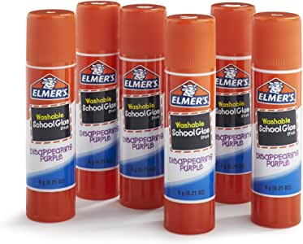
4 Packages of HB pencils | 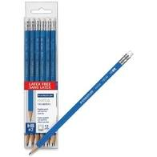
2 pkg Crayola markers | 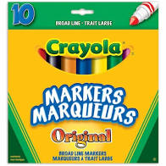
2 pkg colored pencils (Crayola or Staedtler) | 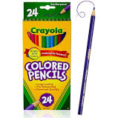
4 pkgs Crayola crayons | 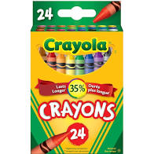
2 white erasers | 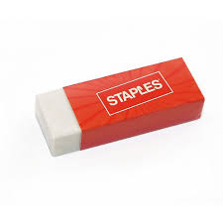
3 soft duo-tangs WITHOUT pockets (different colors) no binders please | 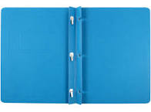
1 soft plastic duo-tang with pockets, no binders please | 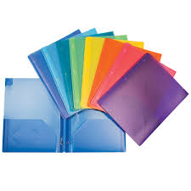
1 message bag (pochette/courier bag)  - size recommendation 15 inches x 10.2 inches  - preferably nylon or durable material  - Recommended colors: green, red, light blue, grey (preferably not a dark color) | 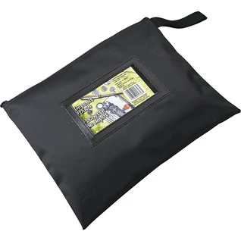
3 boxes of large ziplock bags | 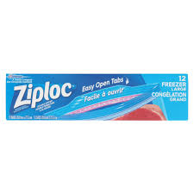
6 containers play doh | 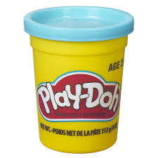
1 soft fabric pencil case (with zipper) large enough to hold supplies (approx. size 8 x 12 inches or about the size of a piece of paper) | 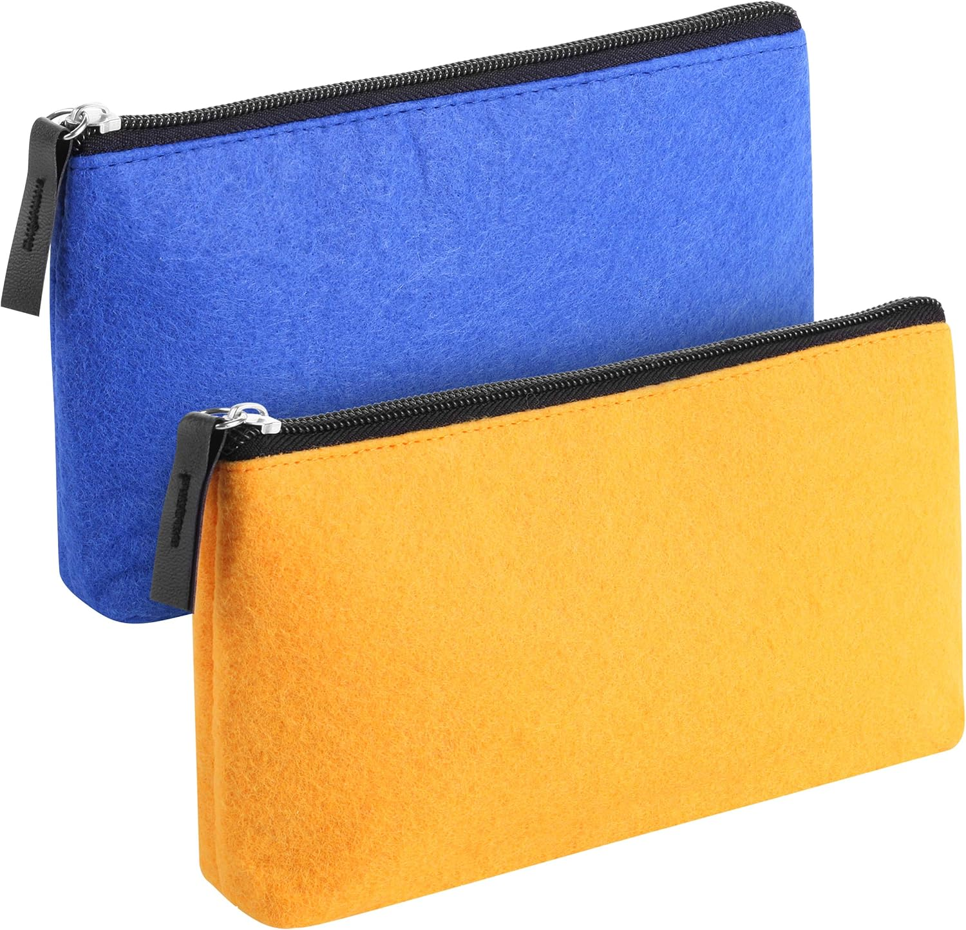
3 packages white board markers (12 markers altogether) | 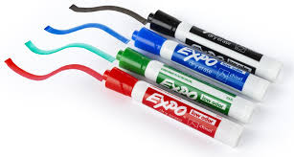
1 pair of indoor shoes  (students should be able to put them on and take them off independently)  No crocs or sandals please (they will use for gym class) | 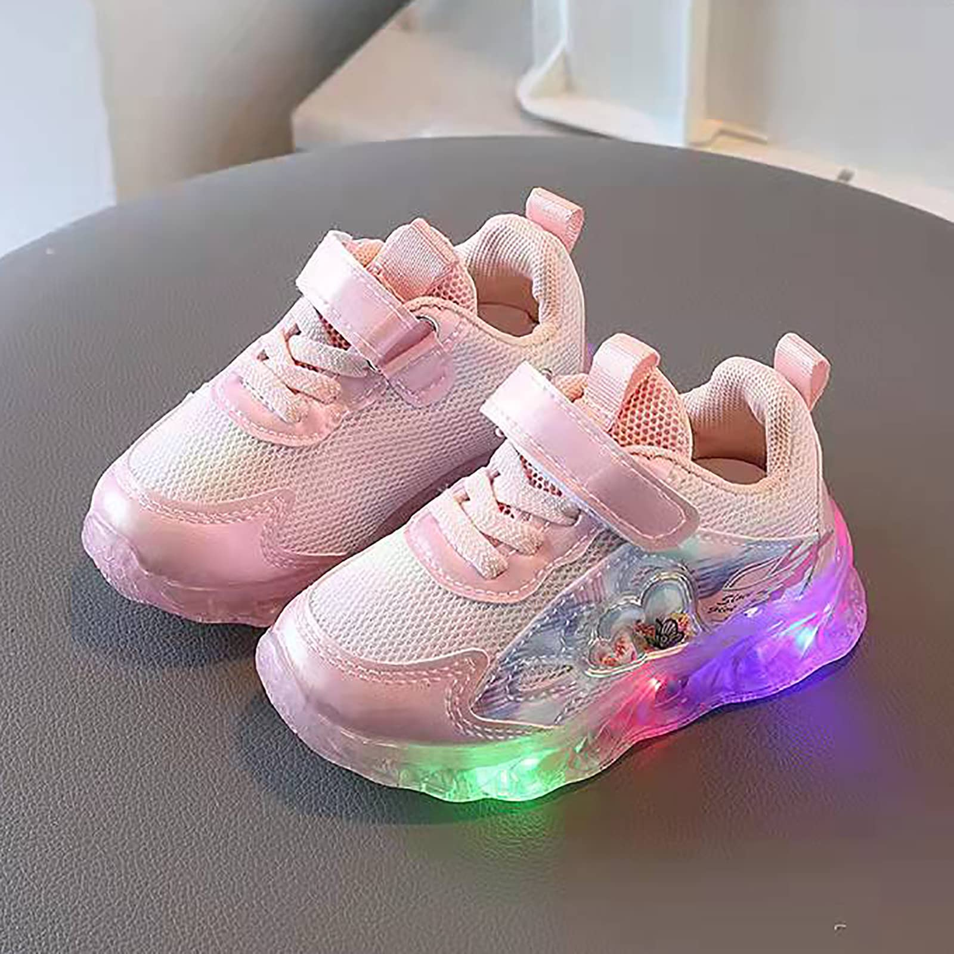
(optional) 1 box of tissues | 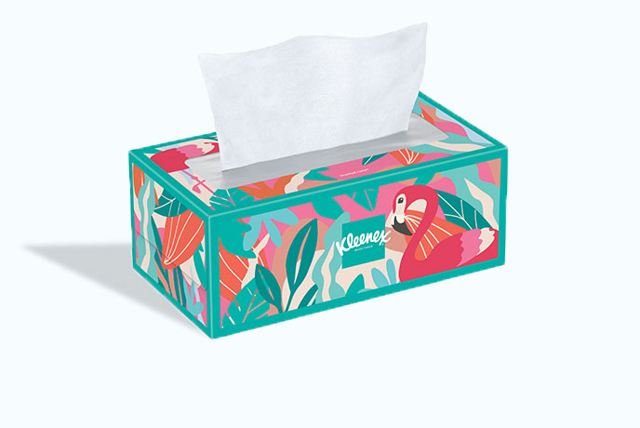
(optional) 1 package of baby wipes (unscented) | 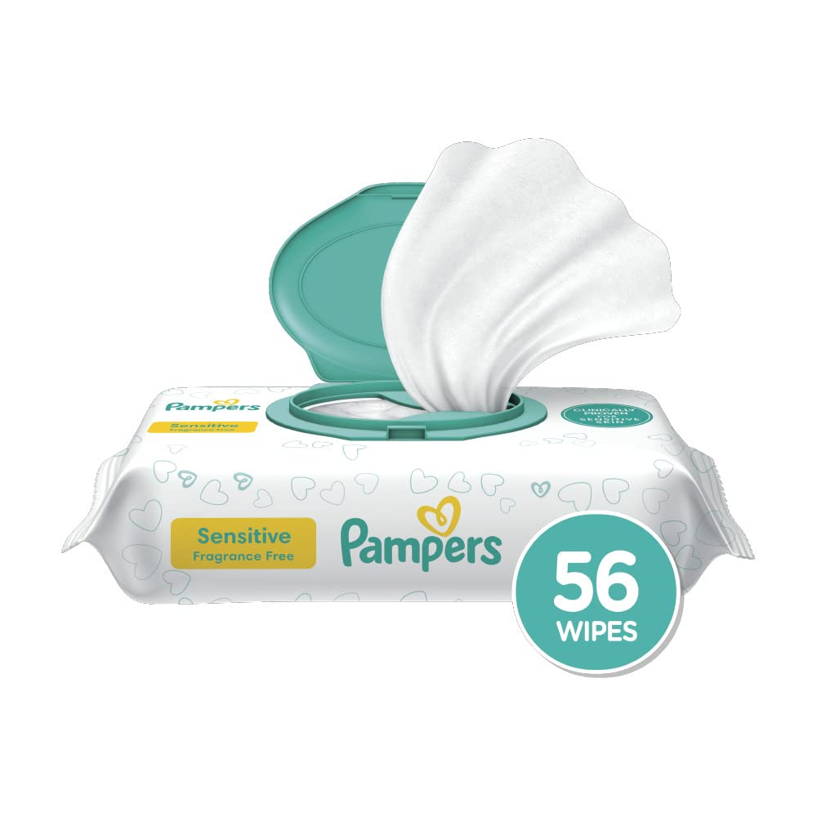
(optional) 1 pack of sidewalk chalk | 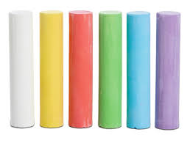

Note: We strive to create supply lists that are as accurate as possible. There may be times however when minimal additional supplies will be needed throughout the year.

Please ensure that all of your child’s items are labeled. You don’t have to label each individual pencil, but please label the box. Thank you very much!

