Primary/One supply list
Number per student on left – total for a class of 22 on the right
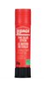
4 large white glue sticks (TOTAL number – 88)
Hamster # 671487 (595-665171)
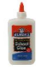
1 white glue (TOTAL number – 22)
Hamster # 270744 (840-60308Q)
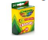
4 packages of crayons (TOTAL number – 88)
Hamster # 129874 (145-52-0016)
1 pair of children’s scissors (TOTAL number – 22)
Hamster # 454611 (015-40005)
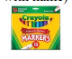
1 package of large tip markers (TOTAL number – 22)
Hamster # 120121 (145-56-7708)

4 - 2 pocket folders (TOTAL number of each colour – box of 25)
Hamster #222752 (740-06026) light blue
Hamster #113407 (740-06007) RED
Hamster #222745 (740-06004) YELLOW
Hamster #113399 (740-06006) GREEN
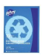
2 72-page Exercise Books (no lines) (TOTAL number – 44)
Hamster # 225631 (740-12154R)
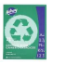
2 72-page Exercise Book (1/2 plain, ½ lined (TOTAL number – 88)
Hamster # 347013 (740-12155R)
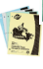
1 Hilroy scribbler (TOTAL number – 6 packages- 4 per package )
Hamster # 546457 (740-12692)
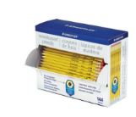
Pencils 1 Bulk box of 144 pencils
Hamster # 595488 (900-13247C144)

2 erasers 2 Bulk boxes - (20 per box)
(TOTAL number of boxes to purchase – 2)
Hamster # 240523 (900-525 B20)
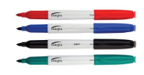
Pack of 4 whiteboard markers (TOTAL number - 22)
Hamster # 1008077 (531-ITA01019)
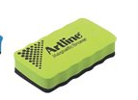
1 small whiteboard eraser (TOTAL number – 22)
Hamster # 456517 (031-ERT-MM)

1 package of blank index card (TOTAL number – 22)
Hamster # 646505 (735-30)
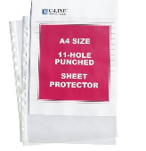
Clear Sheet Protectors Box of 50
Hamster # 1038363 (511-08013)

PURCHASE AT DOLLARAMA???
Cheaper than Hamster….
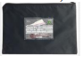
1 courier bag
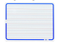
1 small whiteboard

