Grade 3 French immersion Supply list
School Supply Item | A visual to help in purchasing - please note this is just a suggestion and this specific brand is not required
2 packs of pre-sharpened pencils (Minimum of 10 pencils per pack) | 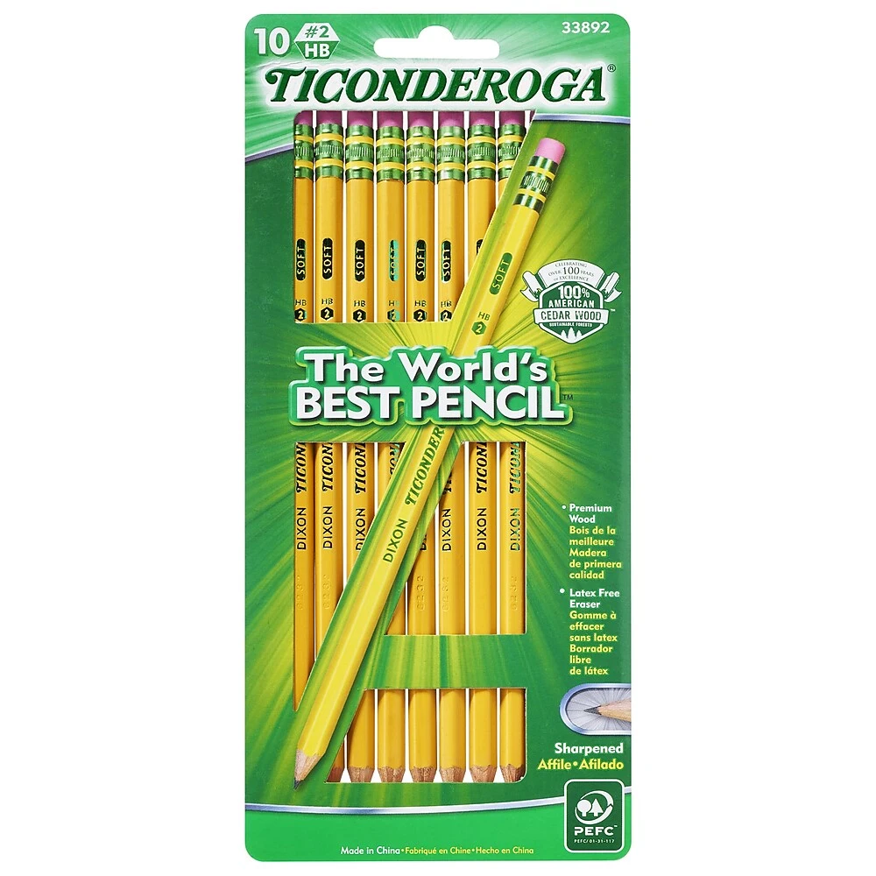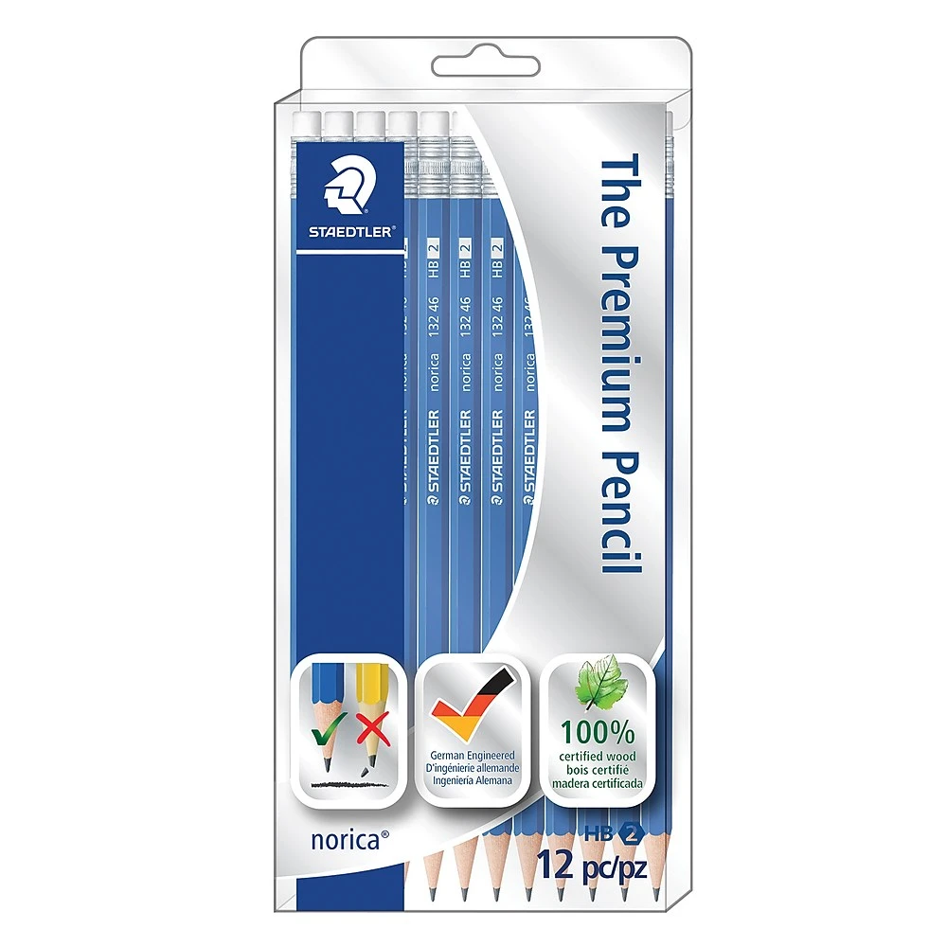
2-3 large glue sticks | 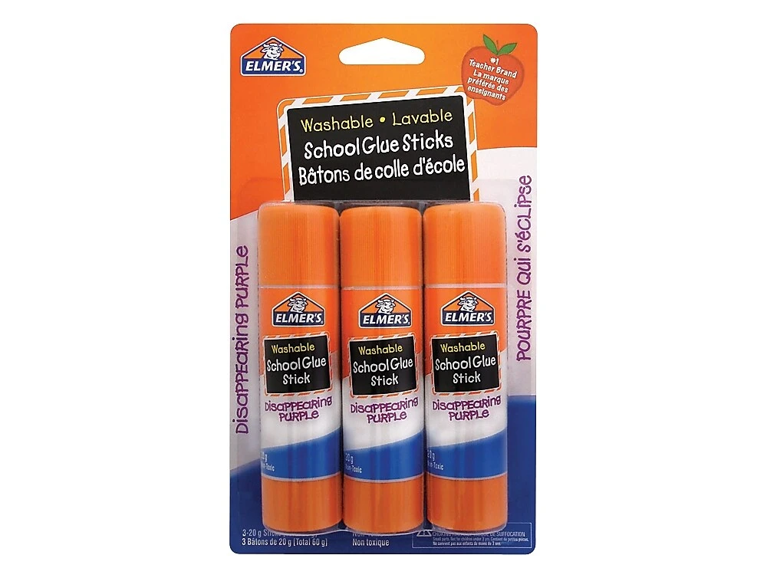
1 large pencil case | 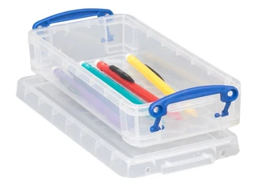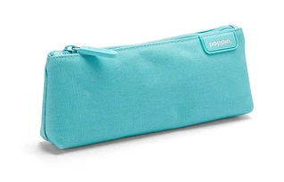
Pack of erasers | 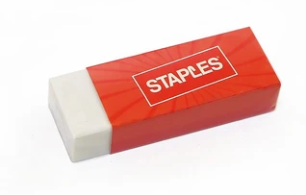
Pack of sharpeners | 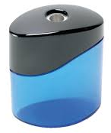
1 Duotang with pockets in Purple  1 Duotang with pockets in Orange  1 Duotang with pockets in yellow  1 Duotang with pockets in green  1 Duotang with pockets in Blue  1 Plastic Duotang with pockets in Red | 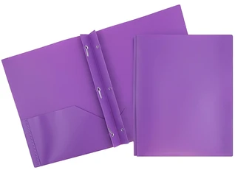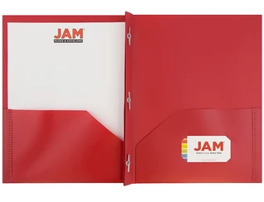
1 pack of4 Hilroy scribblers | 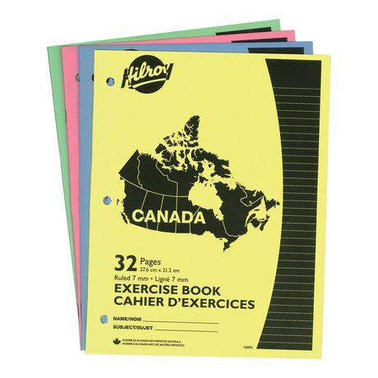
1 pack of coloured pencils  1 pack of markers | 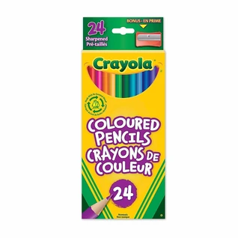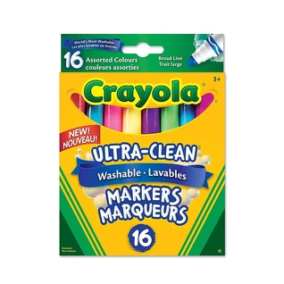
1 pair of scissors | 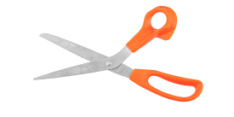
1 pack of white board makers (4-8 markers in a pack) | 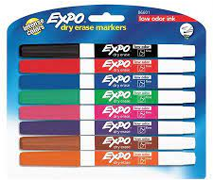
1 Messenger bag | 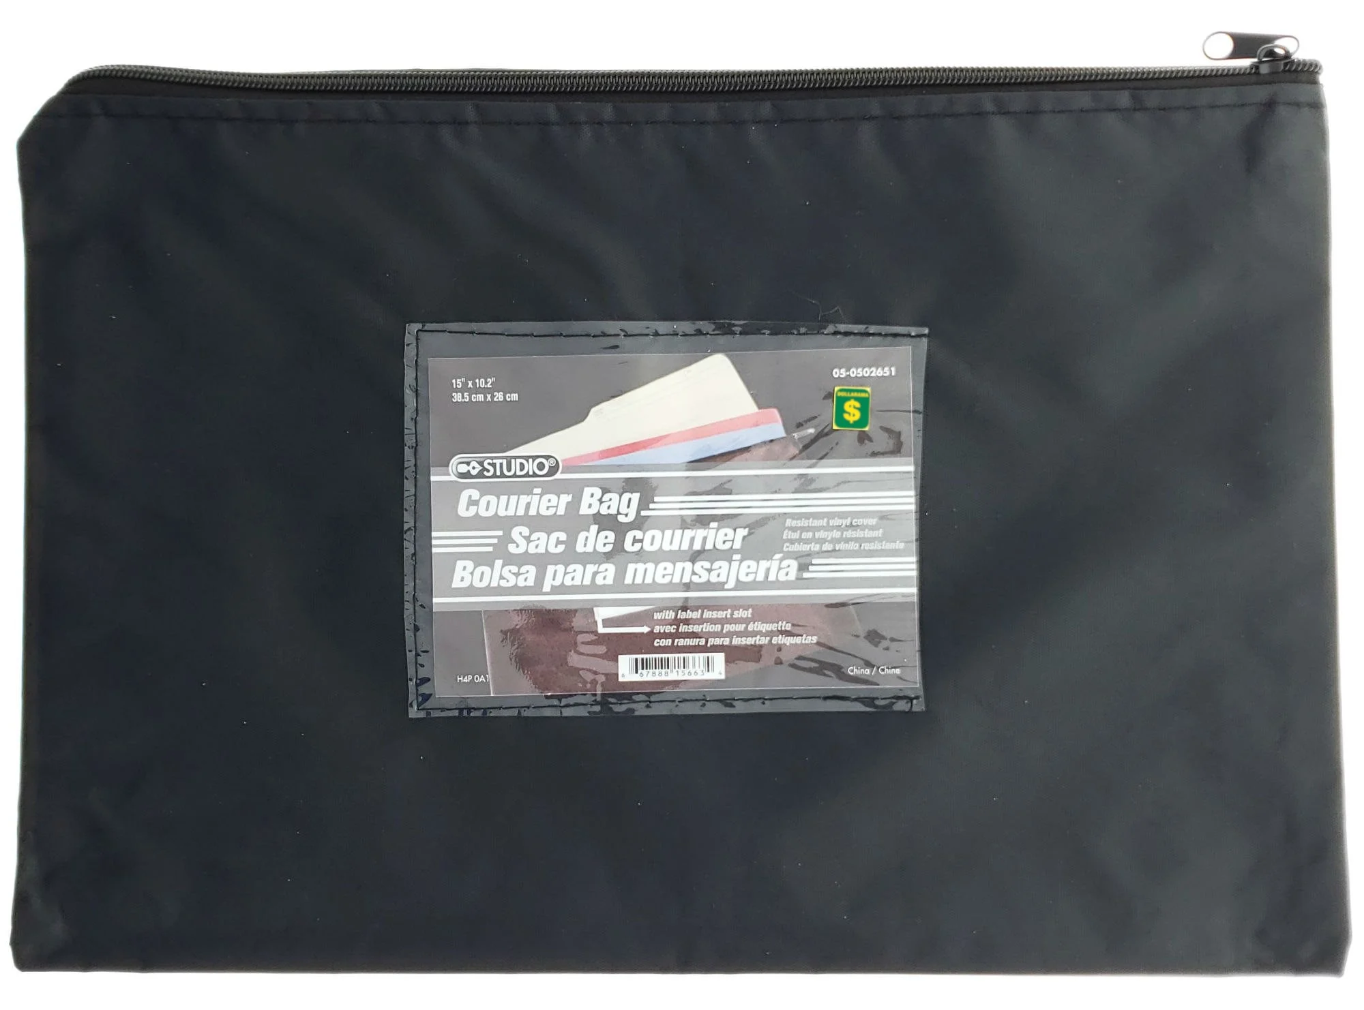
1 30 cm ruler | 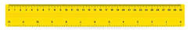
1 Artists Notebook | 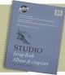
1 Reusable water bottle (optional) | 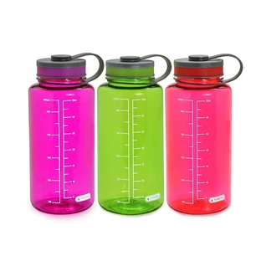
(optional) 1 box of kleenex
1 pair of headphones for chromebook use

