Grade 3 English Supply List

2026/2027
School Supplies  𝥷 80 HB Pencils (good quality, pre-sharpened)  𝥷 6 White Erasers  𝥷 Pencil Sharpener (good quality, shaving receptacle)  𝥷 Coloured Pencils - 24 pack (pre-sharpened)  𝥷 Thin Coloured Markers - 24 pack  𝥷 Crayons - 24 pack  𝥷 8 Black Sharpies (4 ultra fine point, 4 fine point)  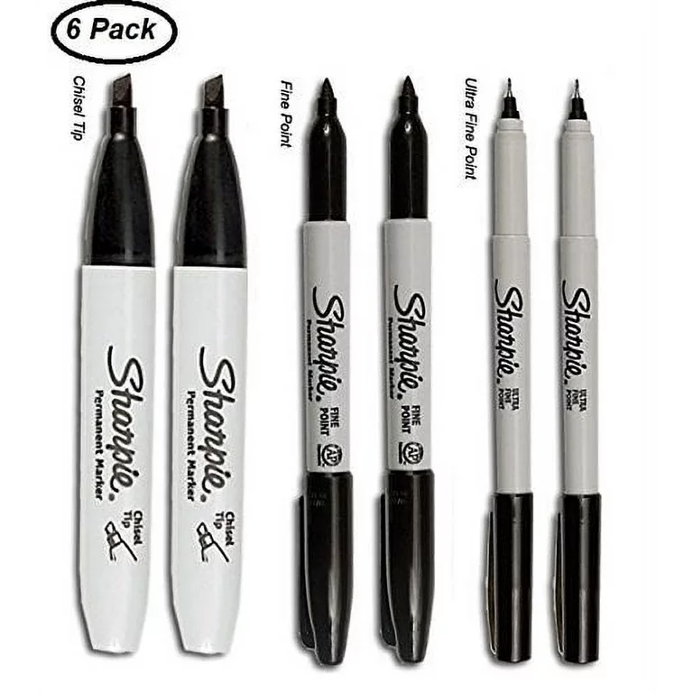  𝥷 3 Glue Sticks (larger size)  𝥷 1 Pair of Scissors (good quality)  𝥷 Small Kit Box (rectangular one to fit art supplies)  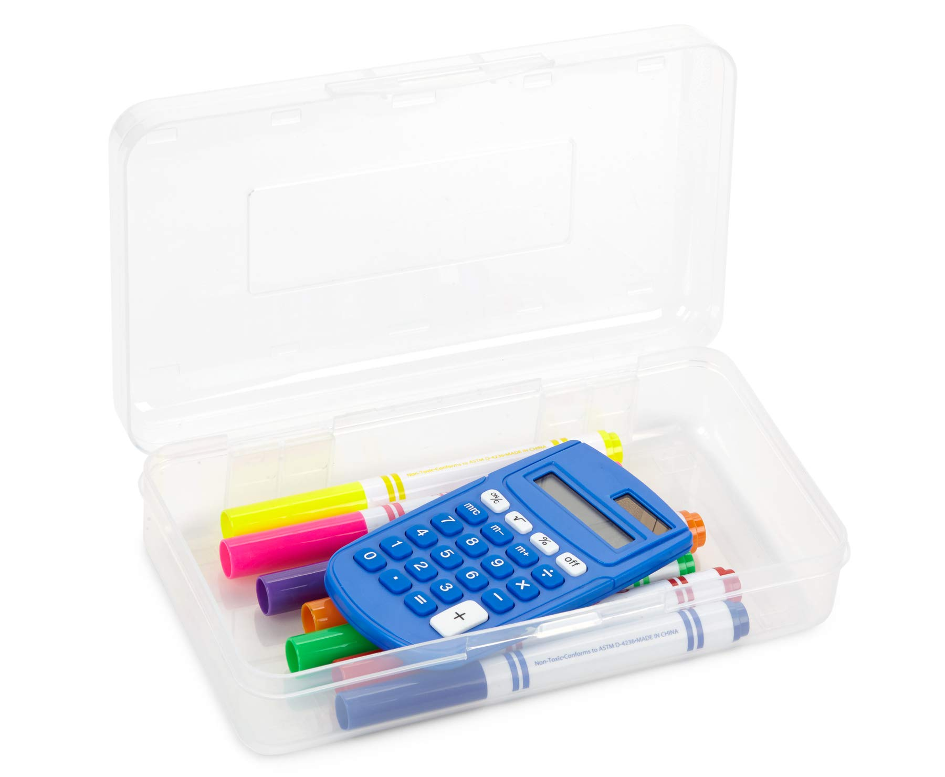  𝥷 Small Pencil Case (cloth one to fit pencils, erasers, sharpener)  𝥷 Page Protectors (10 pack)  𝥷 5 plastic pocket folders with 3 prongs (in different colours)  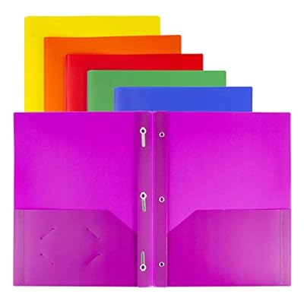  𝥷 10 Whiteboard Markers (good quality)  𝥷 Metric Ruler (30cm)  𝥷 Hard Covered Notebook (Writer’s Notebook)  𝥷 1 Hilroy scribbler, 32 pages (any colour)  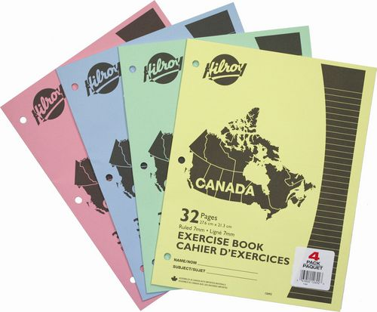  𝥷 Headphones  𝥷 1 rigid cover duo-tang (colour of choice for homework) | Other Required Items  𝥷 Indoor Footwear  𝥷 Backpack  𝥷 Water Bottle (non-metal)  Optional items for your consideration:  𝥷 1 Box of Ziploc Bags (sandwich or large size)  𝥷 1 Box of Tissues  𝥷 1 Package of Wipes

