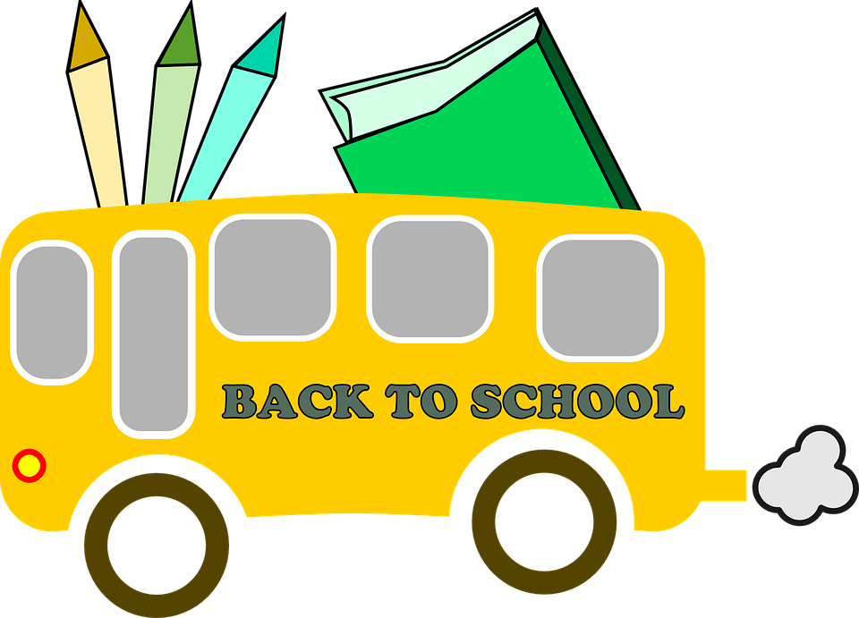 LMST Grade One Supply List for 2026-27

Please send all supplies in a large bag labelled with your child’s name. Please do NOT label individual school supplies unless indicated below.
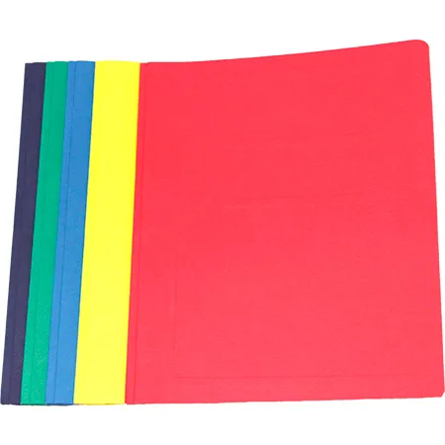  1 RED 3-hole duotang  1 YELLOW 3-hole duotang  1 BLUE 3-hole duotang | 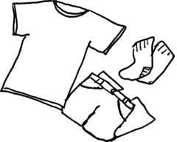  A change of clothes in a ziplock bag (shirt, pair of shorts, underwear and socks)Labeled with your child’s name
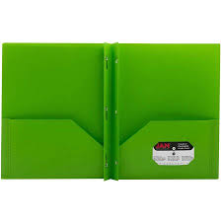  2 plastic pocket folder duotangs with fasteners. (any colour) | 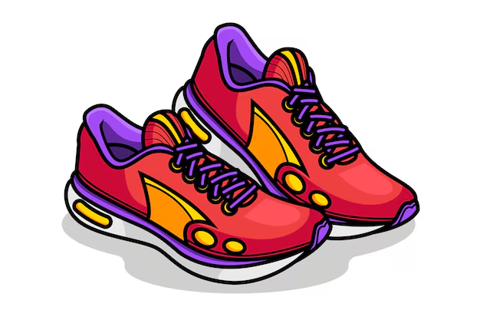  1 pair of indoor sneakers (velcro is best - please label)  *Please only send tie-up shoes when students can consistently do it independently.
40 pencils (sharpened)  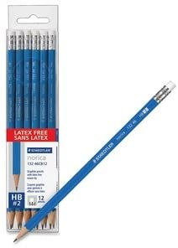 | 1 pair of safety scissors (can be the same pair they used in Primary - label)  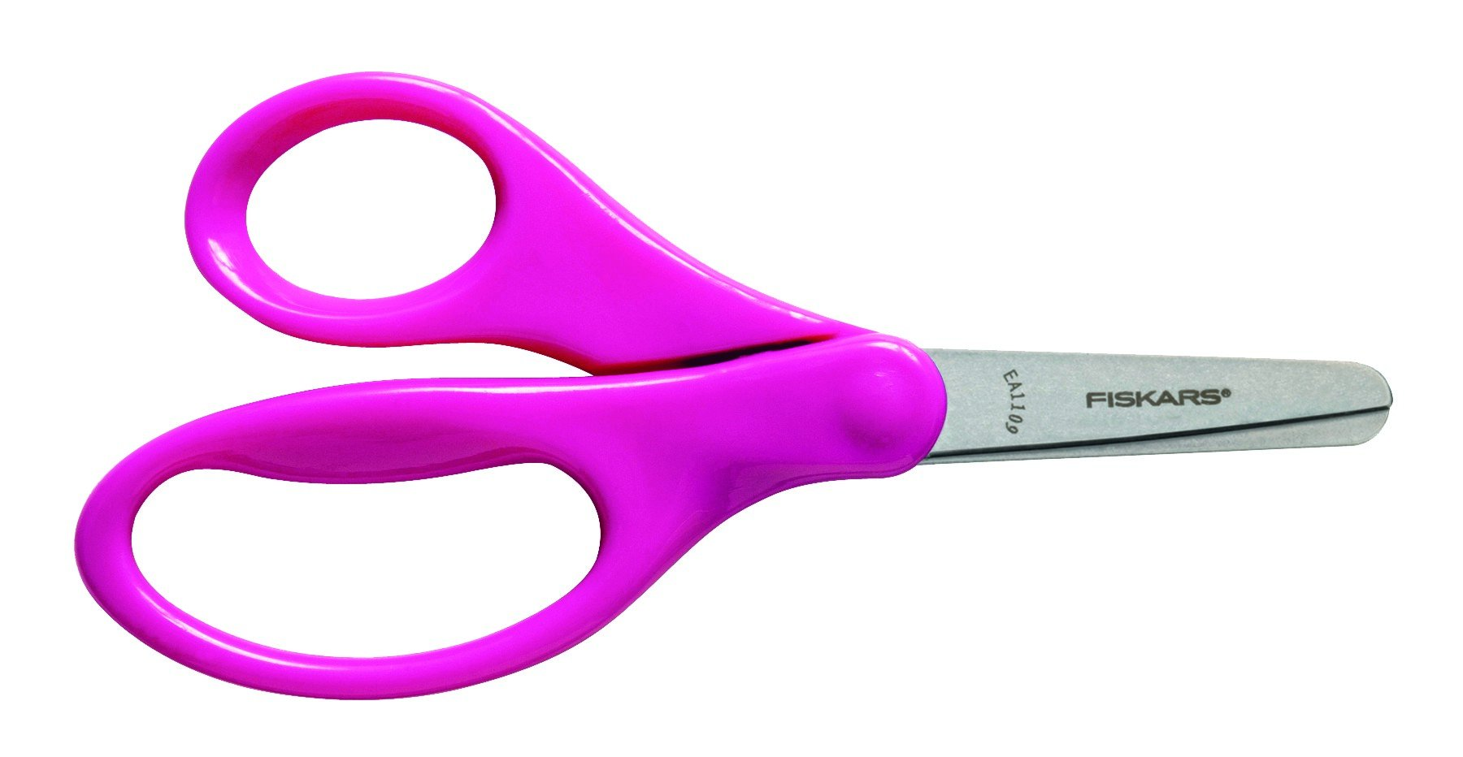
6 small glue sticks ( purple glue is best)  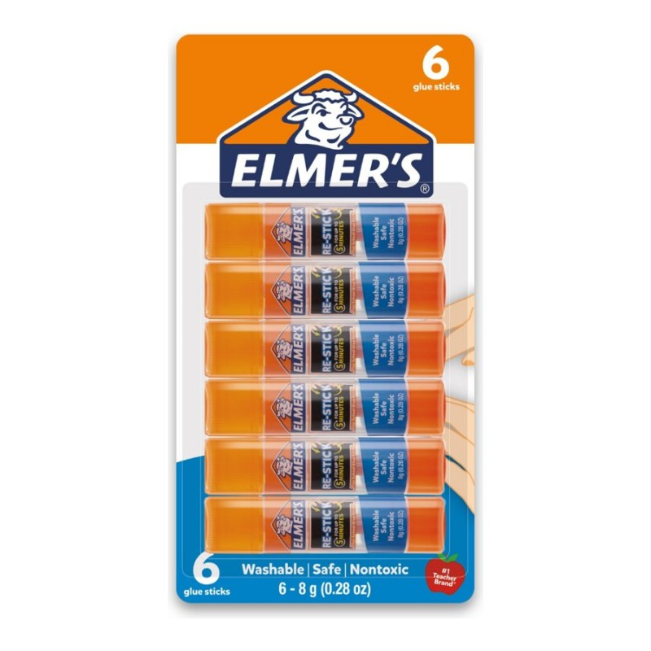 | 2 packs of crayons (24 crayons in each)  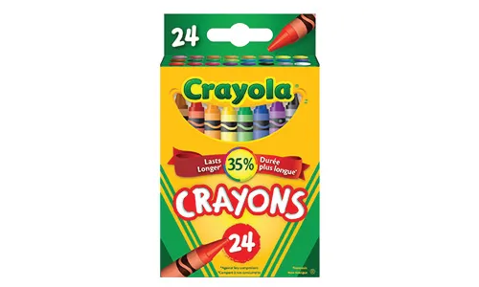
2 Interlined Notebooks (half of the page is lined and then it’s blank on top- Hilroy 1 green, 1 yellow 72 pages)  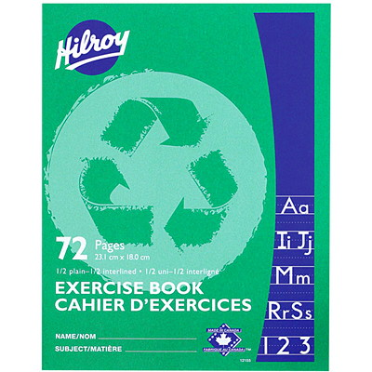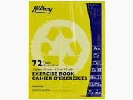 | 2 white erasers  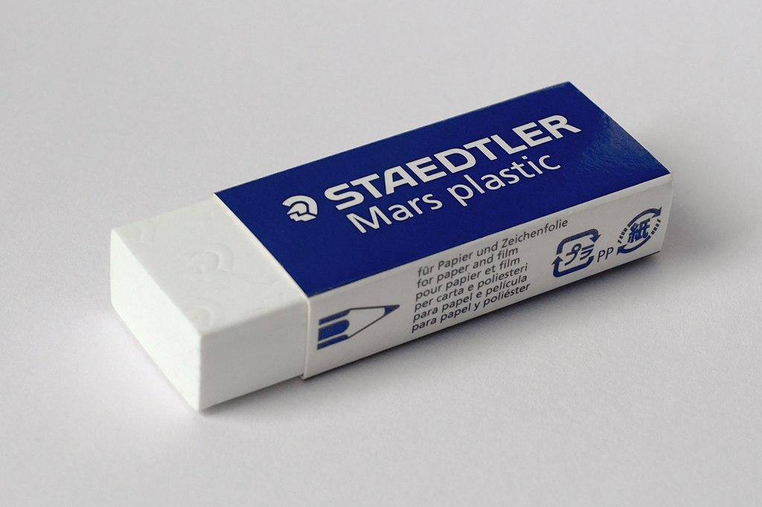
1 package markers (12-pack, unscented)  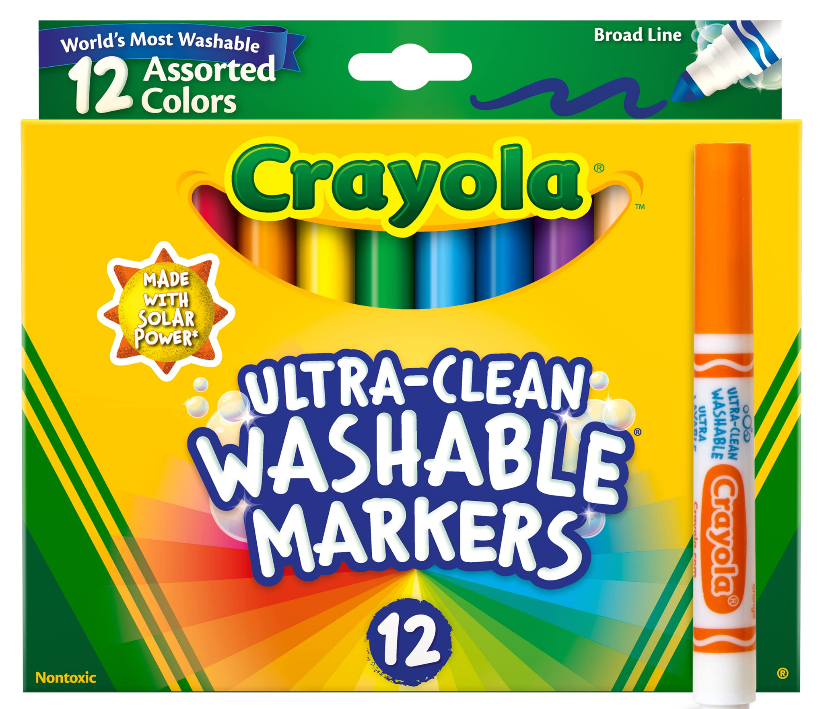 | 1 large zippered messenger bag as it needs to fit an agenda - please label (any color and can buy at Dollarama “Courier bag”)  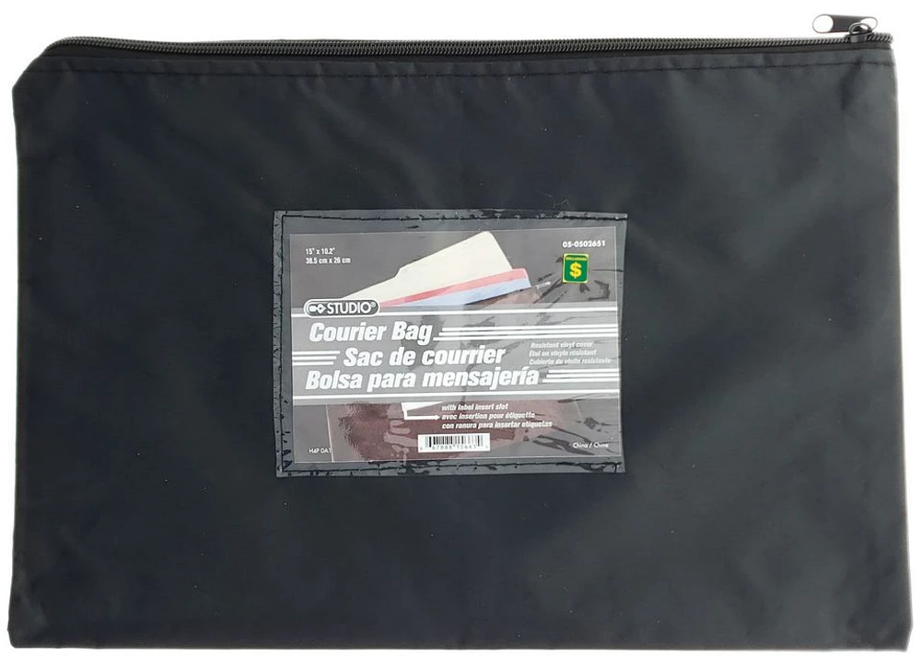
1 black fine tip sharpie marker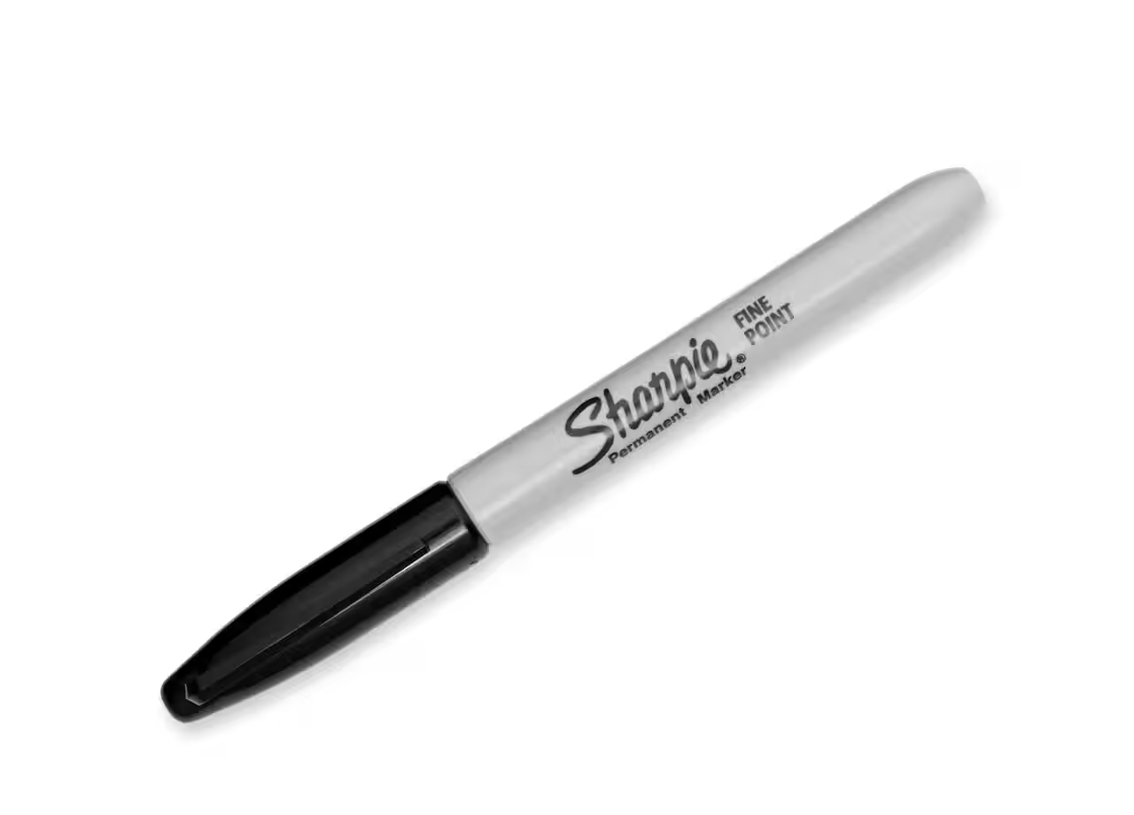 | Standard size plastic pencil box - please label  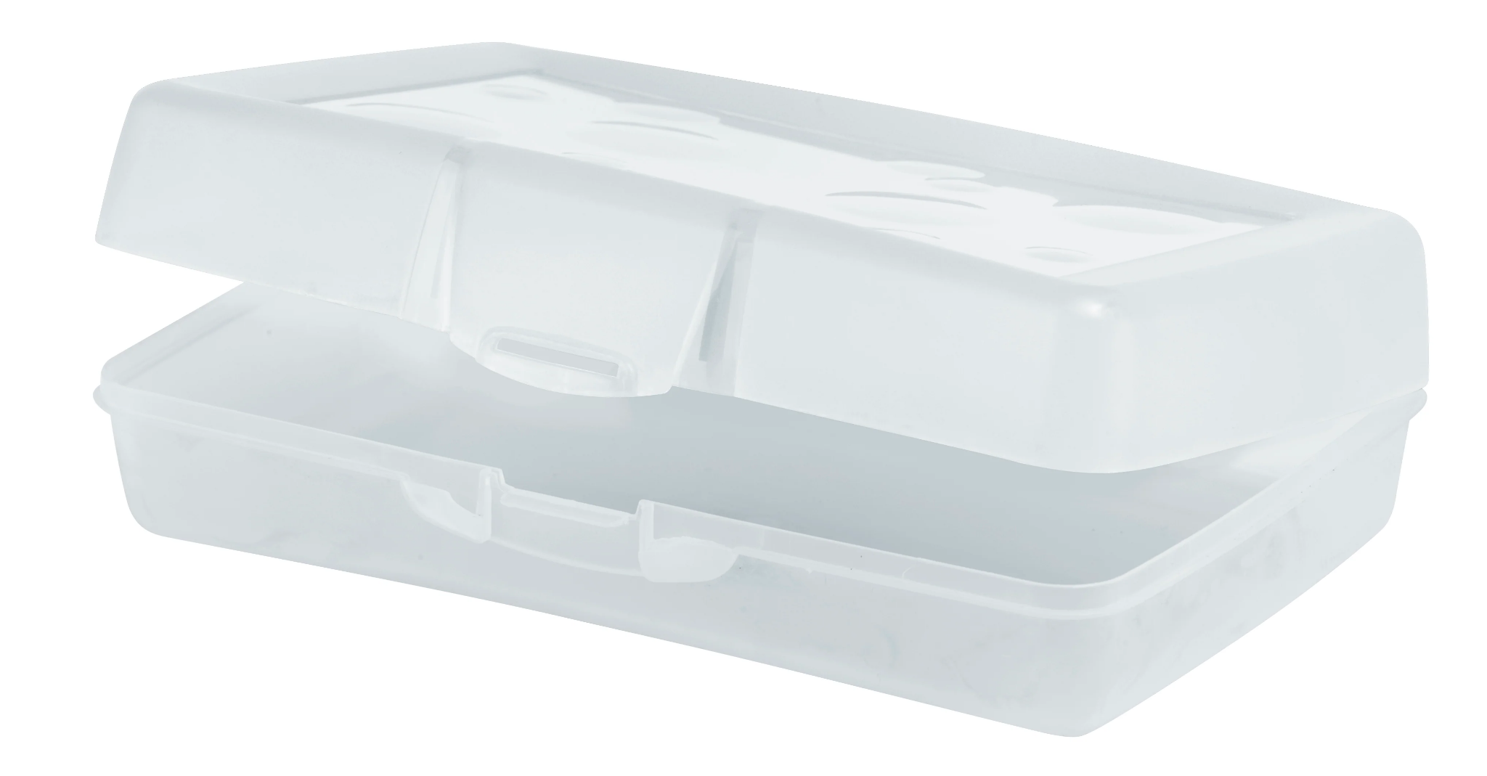
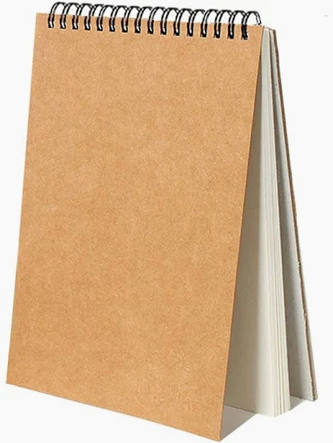  A sketchpad or scribbler with blank ( no lines) pages for drawing. | 1 box of 24 colored pencils  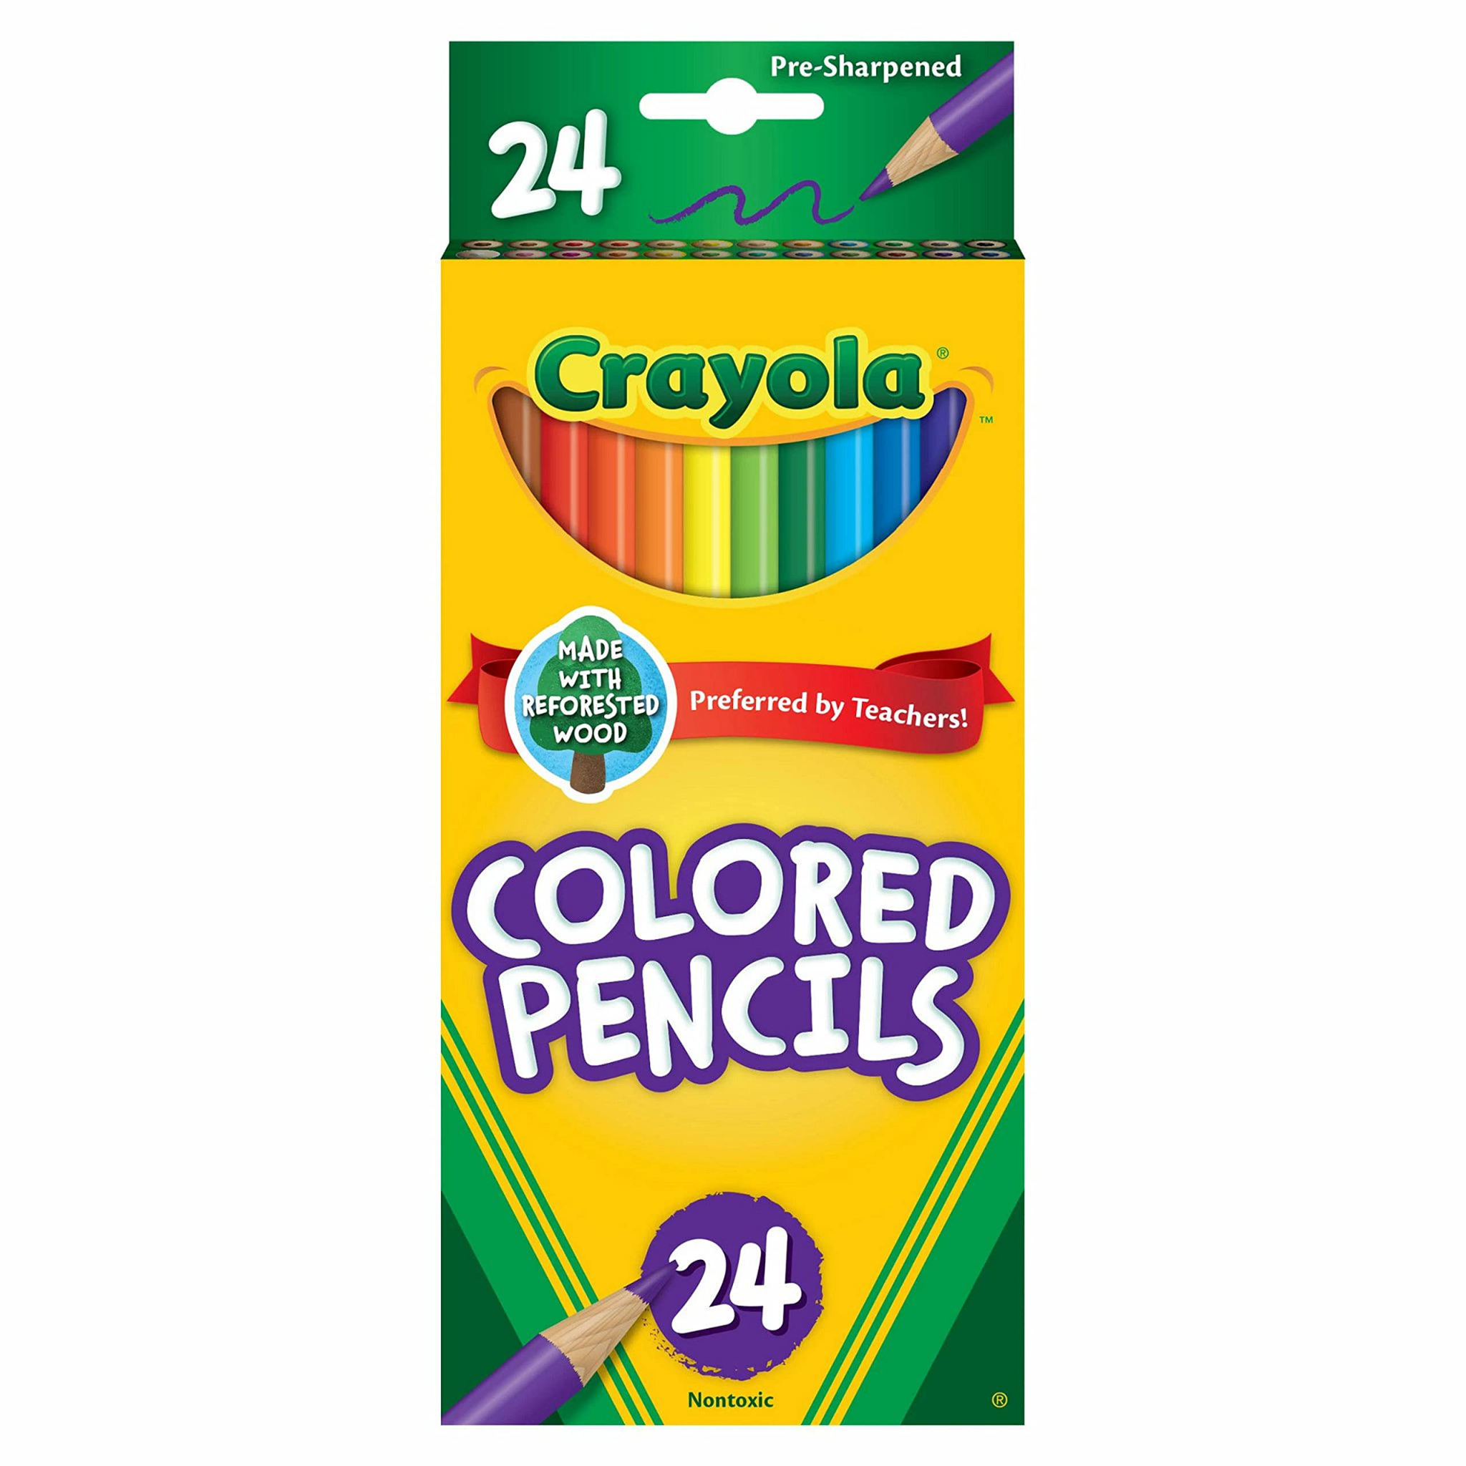
Donation Items for the classroom (optional):
- 1 large box of Kleenex
- Large size ziploc bags
- Wet wipes (baby wipes)

