 | Respect for yourself | Respect for learning | Respect for others | Respect for property
Respect in the Hallway/on the stairs | - Walk to the right  - Walk calmly at all times  (running, jumping, sliding is unsafe.)  - Keep moving  - Look where you are going  - Stay behind the person in front of you | - Walk quietly  - Be on time when transitioning to specialist classes  - Transitions should be led by a teacher  - Go directly to your destination | - Keep your hands and feet to yourself.  - Stay to the right  - Use indoor voices  - Let younger classes lead (allow them to go first)  - Keep belongings in their designated spaces off the floor. | - Wear indoor shoes  - Change your shoes when going outside  - Respect hallway displays  - Hang up your belongings and take them home at the end of the day
Respect in the Classroom  (English and French) | - Do your BEST work  - Listen to and follow directions  - Communicate in the language being used in the classrooms.  - Ask when you need help.  - Practice an “I can attitude” (growth mindset) | - Be prepared  - Do your work  - Use time wisely  - Concentrate  - Participate  - Be open to new ideas  - Be respectful of deadlines | - Be on time  - Work quietly  - Listen carefully  - Wait your turn  - Speak with respect  - Respect others' ideas and efforts | - Take responsibility for your belongings  - Wear indoor shoes  - Respect School Property  - Ask before using something that doesn’t belong to you.  - Respect the property of others
Respect during lunchtime | - Use acceptable language  - Sit on your chair and take the time to eat your own lunch  - Look after your belongings and space  - Use an indoor voice | - Listen to and respect the lunch monitors and grade 6 leaders.  - Sit in assigned seats (eating/quiet activity) for first 15 minutes | - Listen and respect others  - Use your hands for helping  - Play gently  - Share the space  - Use an indoor voice | - Use appropriate bins for food waste and garbage  - take responsibility for your belongings  - Respect school property  - wear appropriate shoes for indoor/outdoor
Respect in Assemblies | - Sit calmly and listen | - We enter and exit the gym calmly  - We are active listeners during presentations  - Stay focused and enjoy the presentation | - Clap (jazz hands) at the right times and keep hands to yourself | - Be mindful of assembly equipment
Respect in the Library | - Choose books that are “just right” for you | - Spend your time listening, reading or researching  - Indoor voices | - Read quietly  - Keep the area tidy.  - Return your books on time | - Handle books with care  - Wear indoor shoes  - Replace lost or damaged books
Respect in the Gym and Music class | - Participate to the best of your ability  - Wear appropriate clothing and indoor sneakers  - Listen to and follow directions | - Participate  - Be prepared  - Follow directions  - Play fairly  - Have a positive attitude  - Always do your best | - Use an indoor voice  - Play safely  - Include and encourage others  - Be kind to your classmates; be a good team player. | - Respect the instruments/equipment  - Use the equipment appropriately  - Return instruments/equipment when finished  - Wear indoor shoes
Respect on the Playground  (EN) (FR) | - Use acceptable language and actions  - Play safely  - Be active  - Dress for the weather  - Be responsible for your belongings | - Try new games  - Take turns  - Play fairly  - Be inclusive. | - Lead by example.  - Hands are for helping  - Play gently  - Share the space  - Stay in your play area  - Wear outdoor shoes | - Respect the environment  - Use equipment as it is intended to be used  - Report problems to a safe adult (adult in yellow vest)
Respect in shared areas (alternate workspaces, pods, outdoor classroom) | - Choose a space where you can focus and do your best (free from distractions) | - Stay on task and follow your learning plan  - Speak the language of instruction  - Remember, working in this space is a privilege | - Use a quiet voice  - Do your work  - Speak the language expected (French/English) | - Tidy up your workspace and return materials carefully
Respect for clubs and extra activities  (musical, chess, maker-space, band, choir, run club, sports…) | - Be on time and show commitment to attendance  - Come prepared and ready to try your best  - Have a positive attitude | - Listen to instructors and follow directions  - Ask questions and stay focused  - Keep practicing and growing | - Encourage others  - Take turns and share  - Use kind words and show good sportsmanship  - Respect the time and guidance provided by leaders (teachers/parents/volunteers) | - Use equipment and supplies with care  - Clean up when finished  - Return items to where they belong
Respect for bathrooms | - Use the bathroom when needed  - Wash your hands  - Return to class immediately | - Use your time wisely to get back to learning  - Choose appropriate times to go | - Washing hands  - Clean up after yourself  - Flush the toilet  - Use garbage cans  - Give others privacy | - Leave the bathroom cleaner then you found it  - Flush, wash hands, and throw paper towels in the bin
Respect for travel on Bus | - Stay seated, facing forward.  - Use kind words and inside voices. | - Be on time, wait patiently  - Listen to the adult in charge  - Keep the aisle clear. | - Use kind words and quiet voices.  - Keep your hands and feet to yourself. | - Respect the space—keep the bus tidy for others.

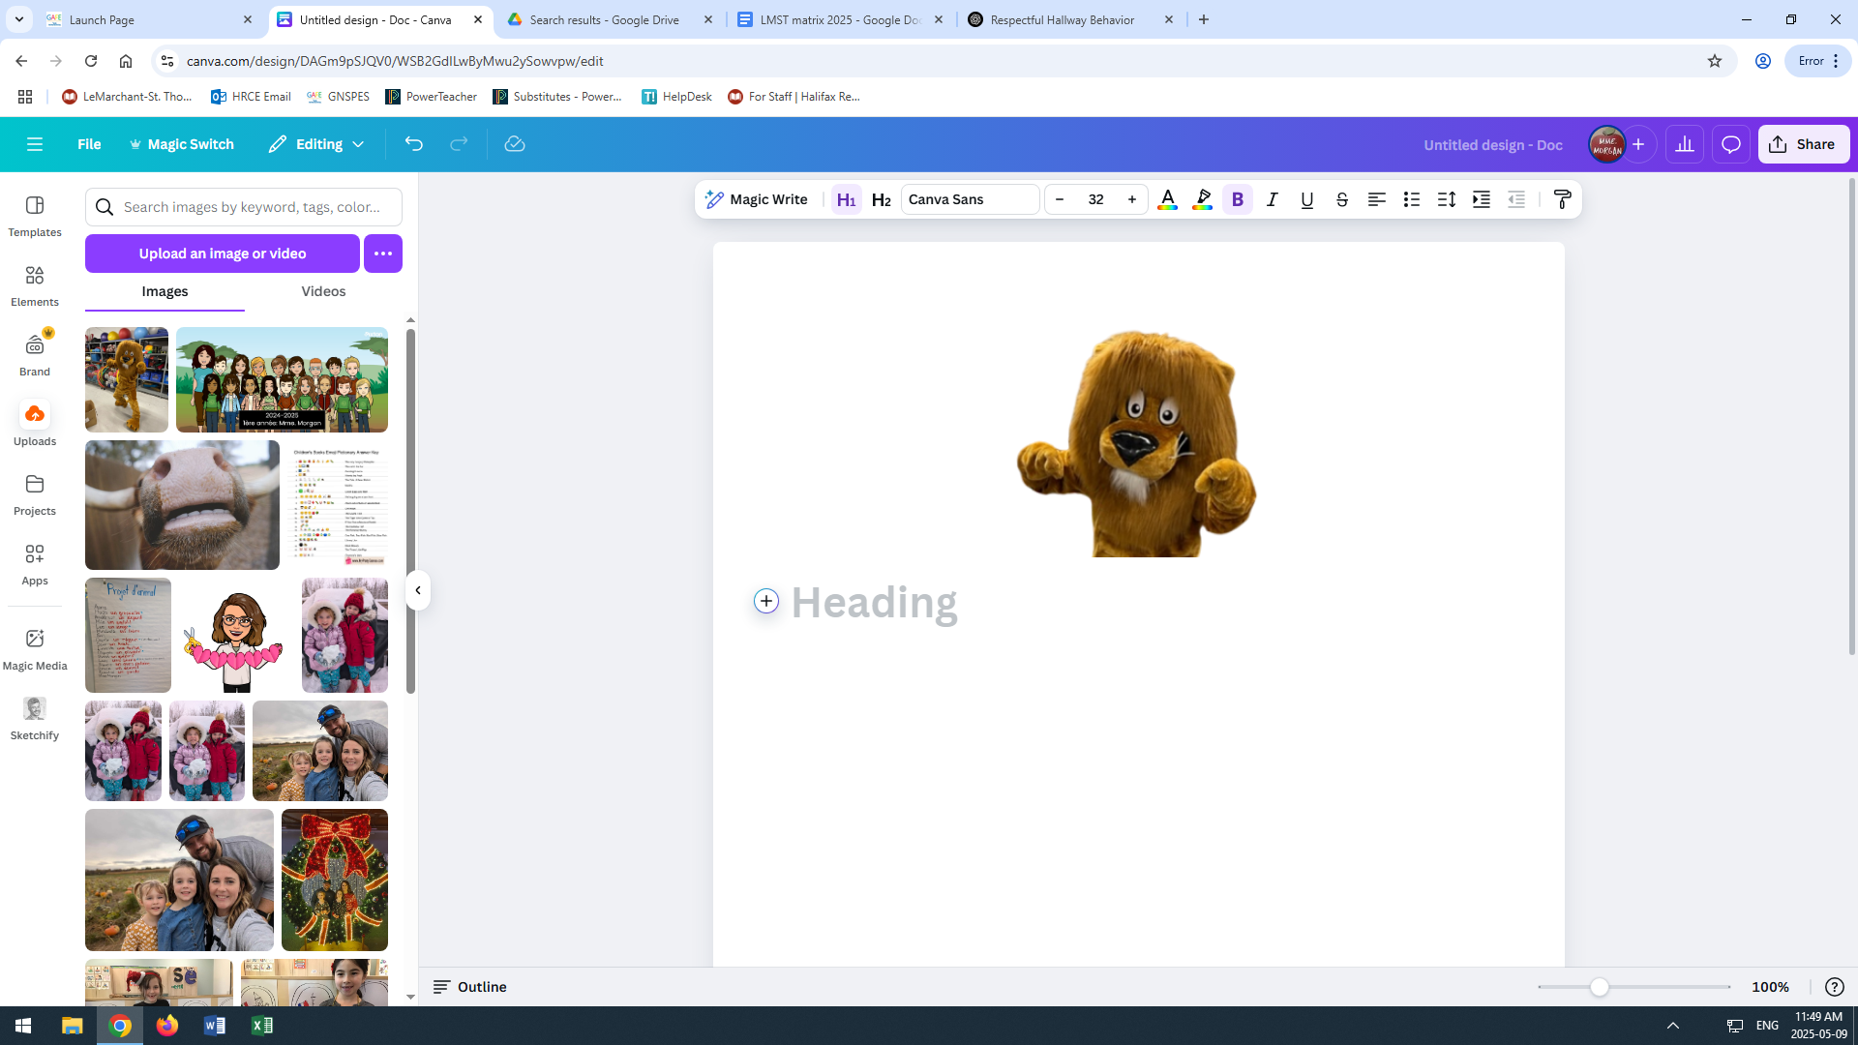

“Roar with Respect, Lead with Kindness!” – Lou the Lion

